Findings from the data analysis of Power Co data

# Validating the price sensitivity hypothesis

## Base price sensitivity

* Price fluctuations during peak and off-peak seasons affect consumer churn.
* Paying a higher price during the off-peak season as compared to the peak season increases the chances of churning in 3 months as shown by the curves below:

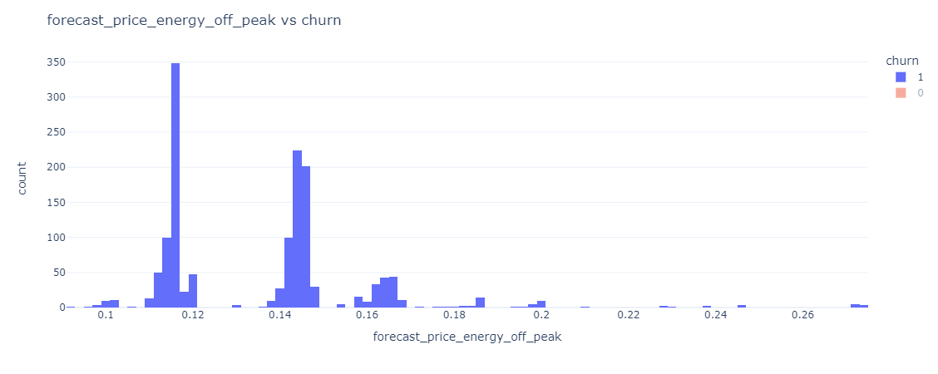

Figure 1: Correlation between off-peak energy prices (forecasted) and churn values.

Figure 2: Correlation between peak energy prices (forecasted) and churn

Furthermore, lack of discounts to be offered to the consumers also resulted in increasing the churn:

Figure 3: Correlation between discounts to be offered and the churn rate of consumers

## Consumer subscription costs

The margin on subscription plans (apart from the base price) has also impacted the consumer churn considerably:

Figure 4: Relation between net subscription costs and churn

* The figure above indicates an inverse relation between the net margin and the churn rate.
* As the distribution for gross margin collected is very similar to the net margin, we can safely exclude the gross margin field for preparing our model.

# Consumer behavior and the impact on churn

Consumer behavior effects can be categorized into the following aspects:

1. History of onboarding
2. Current and forecasted consumption
3. Current billing plans

## Onboarding and plan history

Consumers whose contracts are about to expire (have not renewed) are more likely to churn than consumers who have renewed their contracts:

Figure 5: Contract renewal vs churn

Figure 6: Contract ending vs churn

The timeline corresponding to power liberalization might match with the trend of consumers choosing to not renew their contracts with Power Co.

## Consumption patterns

* Consumers with low consumption have churned out faster than consumers with high consumption. This is validated by the price sensitivity as it is not beneficial to pay high prices for low utilization.
* It is also safe to not consider monthly consumption as it does not reflect on churn (due to the duration of contract)

Figure 7: Annual consumption vs churn

* Additionally, consumers who have not opted for gas connections are also likely to churn out than consumers who have both electricity and gas utilities.

Figure 8: Table illustrating percentage of consumer churn

# Key Takeaways and other required information

The exploratory data analysis has yielded the following results:

1. It has validated the price sensitivity hypothesis as presented by Power Co
2. Consumer behavior, such as contract end duration, availing gas connection and power usage affect churn.
3. Costs paid by the consumer also correlate with the price sensitivity hypothesis – as there is no benefit for the consumer to pay high charges for low utilization of resources.

Some data that might not be considered while preparing the model are:

1. Gross margin on power subscription – as the trends displayed by the net margin and gross margin are quite similar
2. Monthly power consumption – as the annual consumption data accurately represents the relation more than monthly data
3. Date of onboarding – historic association might not be related with consumer churn ratio

Other information that might be required while preparing the model:

1. Timeline of power liberalization – exact dates – to validate the consumer renewal behavior.
2. Units of measurement of power consumption – to ensure uniform quantity.
3. Data on how the margins on subscription are calculated